You are teaching the other members in your group about Coastal Processes. Create a poster to help you teach this process.

Have you ……

- explained the difference between weathering and erosion?

- explained what causes waves?

- defined erosion, transportation (longshore drift) and deposition?

- used diagrams and pictures to show how the process?

- divided the work equally?

- organized who will present what?

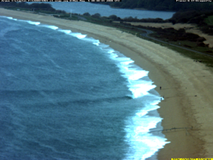

You are teaching the other members in your group about Coastal landforms. Create a poster to help you teach this process.

Have you…

- explained how headlands, bays and wave cut platforms are formed

- Used diagrams or images to explain the processes.

- divided the work equally?

- organized who will present what?

