COASTS
Unit question: Can humans live in harmony with the coastal system?

Significant concept: Should humans interfere with natural systems? Can natural systems be managed?

Area of Interaction: Human Ingenuity - how have humans managed the coast?

Task: video animation

What processes happen along the coastline?

What are the landforms created by these processes?

Include as many key words as you can from the list below:

Backwash

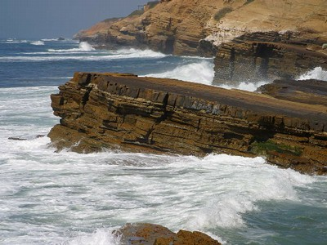
Swash

Erosion

Hydraulic action

Abrasion

Solution

Attrition

Transport

Longshore drift

Deposit

Beach
Task instructions:

- You are going to make a video animation of coastal processes and landforms.
- Duration: 3-5 minutes
- Include labels for the features;
- Narration that explains the key processes. You can include subtitles to make the information clearer.

For an example of what a video animation looks like go to:

http://www.youtube.com/watch?v=vNcdpKRSzHo

Materials you will need:

- Play-Doh/plasticine
- Video camera/phone
- Materials gathered from the beach
- Other materials e.g. toothpicks and labels with key words.
