 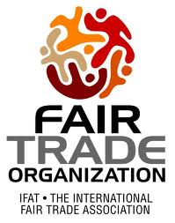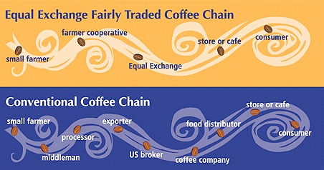

Fair Trade

March 2013

Fair Trade

Sed risus pede, laoreet laoreet, scelerisque vel, eleifend a, enim. Praesent eu urna.

#### Dolor

#### Page 5

In hac habitasse platea dictumst. Nullam pulvinar urna et ipsum.

#### Ipsum

#### Page 3

More about fair trade and organizations

#### Page 2

#### Fair Trade

Continued on

Fair Trade is a trading partnership, based on dialogue, transparency and respect, that tries to achieve greater equity in international trade between the rural workers and the buyers. It contributes to sustainable development by offering better trading conditions to the marginalized workers in the South. It also secures the worker’s right and help them to maintain a healthy living with enough needs to take care of their family

### “Enable produces to improve their livelihood and communities”

# What is Fair Trade?

## Pros:

## Increase income of framers

## Encourages development and investment

## Environment protection

## Promotes a close link between consumers and producers

Cons:

They are much lower for non-processed supplies than for processed goods, this discourage local government to invest on processing facilities.

Most fair trade goods are sold at specialized shops and they aren’t in the mainstream of production.

## Disadvantages & Advantages of fair trade:

Fair Trade organizations have a clear commitment to Fair Trade as the principal core of their mission. They, back by consumers, are engaged to support produces. It raises the awareness in campaigning for changes in the rules and practice of conventional international trade. Products that practice the fair trade can be recognized by the WFTO logo.

WFTO logo

The WFTO is a global organization on Fair Trade with members to secure the right of the workers in maintaining their healthy living  
  
Membership of the WFTO is limited to organizations that demonstrate a 100% Fair Trade commitment. This implies that these organizations have to give certain rights to the workers such as the salary that they deserve, WFTO Members are not just the pioneers of the movement but the innovators of the market.

**“Vision**   
WFTO, the World Fair Trade Organization, has a vision of a world in which trade structures and practices have been transformed to work in favour of the poor and promote sustainable development and justice.   
  
**Mission**WFTO’s mission is to enable producers to improve their livelihoods and communities through Fair Trade.  WFTO will be the global network and advocate for Fair Trade, ensuring producer voices are heard. The interests of producers, especially small farmers and artisans, should be the main focus in all the policies, governance, structures and decision making within the WFTO.”

## Fair Trade organization

Normal production train

Fair Trade-Less firms involved

Continued…

Vestibulum sit amet magna in erat varius volutpat. Proin sodales, felis nec bibendum pharetra, sem arcu bibendum diam, quis pellentesque elit lectus eu velit.

Maecenas pretium cursus nulla. Sed tincidunt cursus diam. Proin dapibus, erat eu fringilla gravida, neque mi pretium massa, ac varius sem orci eu lorem. Nam tempor.

Praesent urna metus, ultrices in, viverra eget, rhoncus a, arcu. Vivamus mi sapien, tincidunt ut, ultricies in, bibendum eu, sem. Nulla facilisi.

#### Sed risus pede, laoreet laoreet, scelerisque vel, eleifend a, enim. Praesent eu urna.



[Street Address]  
[City], [State][Postal Code]

[Web Address]

Lorem Ipsum Dolor

Address Line 1  
Address Line 2  
Address Line 3  
Address Line 4

[Recipient]

Sed libero sem, rutrum vitae, nonummy et, pretium eget, diam. In tristique auctor mi. Fusce sit amet augue. Praesent elementum volutpat lectus. Cras sollicitudin sem eget magna. Sed iaculis erat imperdiet velit. Aliquam vehicula, mauris at pharetra semper, dui arcu lobortis lorem, non faucibus ligula elit vel magna.

Aliquam eleifend, mauris vel pellentesque elementum, massa augue convallis ligula, vestibulum cursus pede lectus at nunc. Sed iaculis massa non tortor. Mauris interdum tincidunt lacus. Donec sit amet velit. Pellentesque congue pharetra est. In ligula arcu, dapibus ac, auctor non, bibendum sit amet, elit. Nullam vel nisl id eros bibendum commodo.

### Vestibulum cursus turpis eget velit. Integer lorem.

# Fusce ac ligula a magna bibendum tempus.

Lorem Ipsum Dolor

Spring 2016