Global population change

- Open Excel and copy the following data exactly.
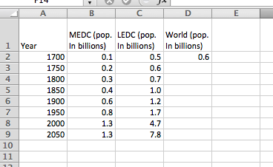
- Rather than typing the data in cell D2 we can make excel do the work for us. Delete 0.6 and type the following:
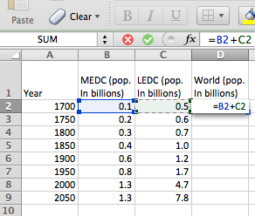

3. Now click and hold the corner on cell D2. Drag down to D9 and excel will work the entire column out for you.

4.Now it’s time to use this data to make a line graph. But first, you need to go back to cell A1 and delete the word ‘Year’, if you don’t your graph won’t work.

- Highlight your data table and then click CHARTS on the tool bar at the top and select line graph. Your line graph should magically appear!

- Your graph is NOT finished – try and work out how to the following:

- Add an appropriate title
- Label the x and y axes
- Reduce the weight (thickness of the lines)
- Rotate the numbers for the years
Eventually it should look something like this…

- Now open WORD. Cut and paste your graph into a new word document.

8. Use text boxes to annotate your graph
- Describe the shape of the graph
- What do you notice about the differences between the population growth in LEDC countries and MEDC countries (we don’t really use those terms much any more but they fit for today)
- Identify when the worlds population reached 1 billion, 3 billion and 8 billion.

