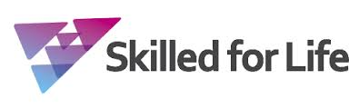
Improving my learner profile

List as many skills you know even if you did or didn’t use them.

Skills

Which of these skills did you use? | Give an example of how you enhanced this skill

How could I improve these skills in the future?

