Indicators of development: How can we measure differences in levels of development?

The big ideas of geography include PLACE, SPACE, SCALE and TIME

In today’s lesson we will consider two indicators of development at different scales. We will consider nutrition at a global scale and marginalisation at a regional scale.

Geographers also need to develop certain skills – today we will be DESCRIBING!

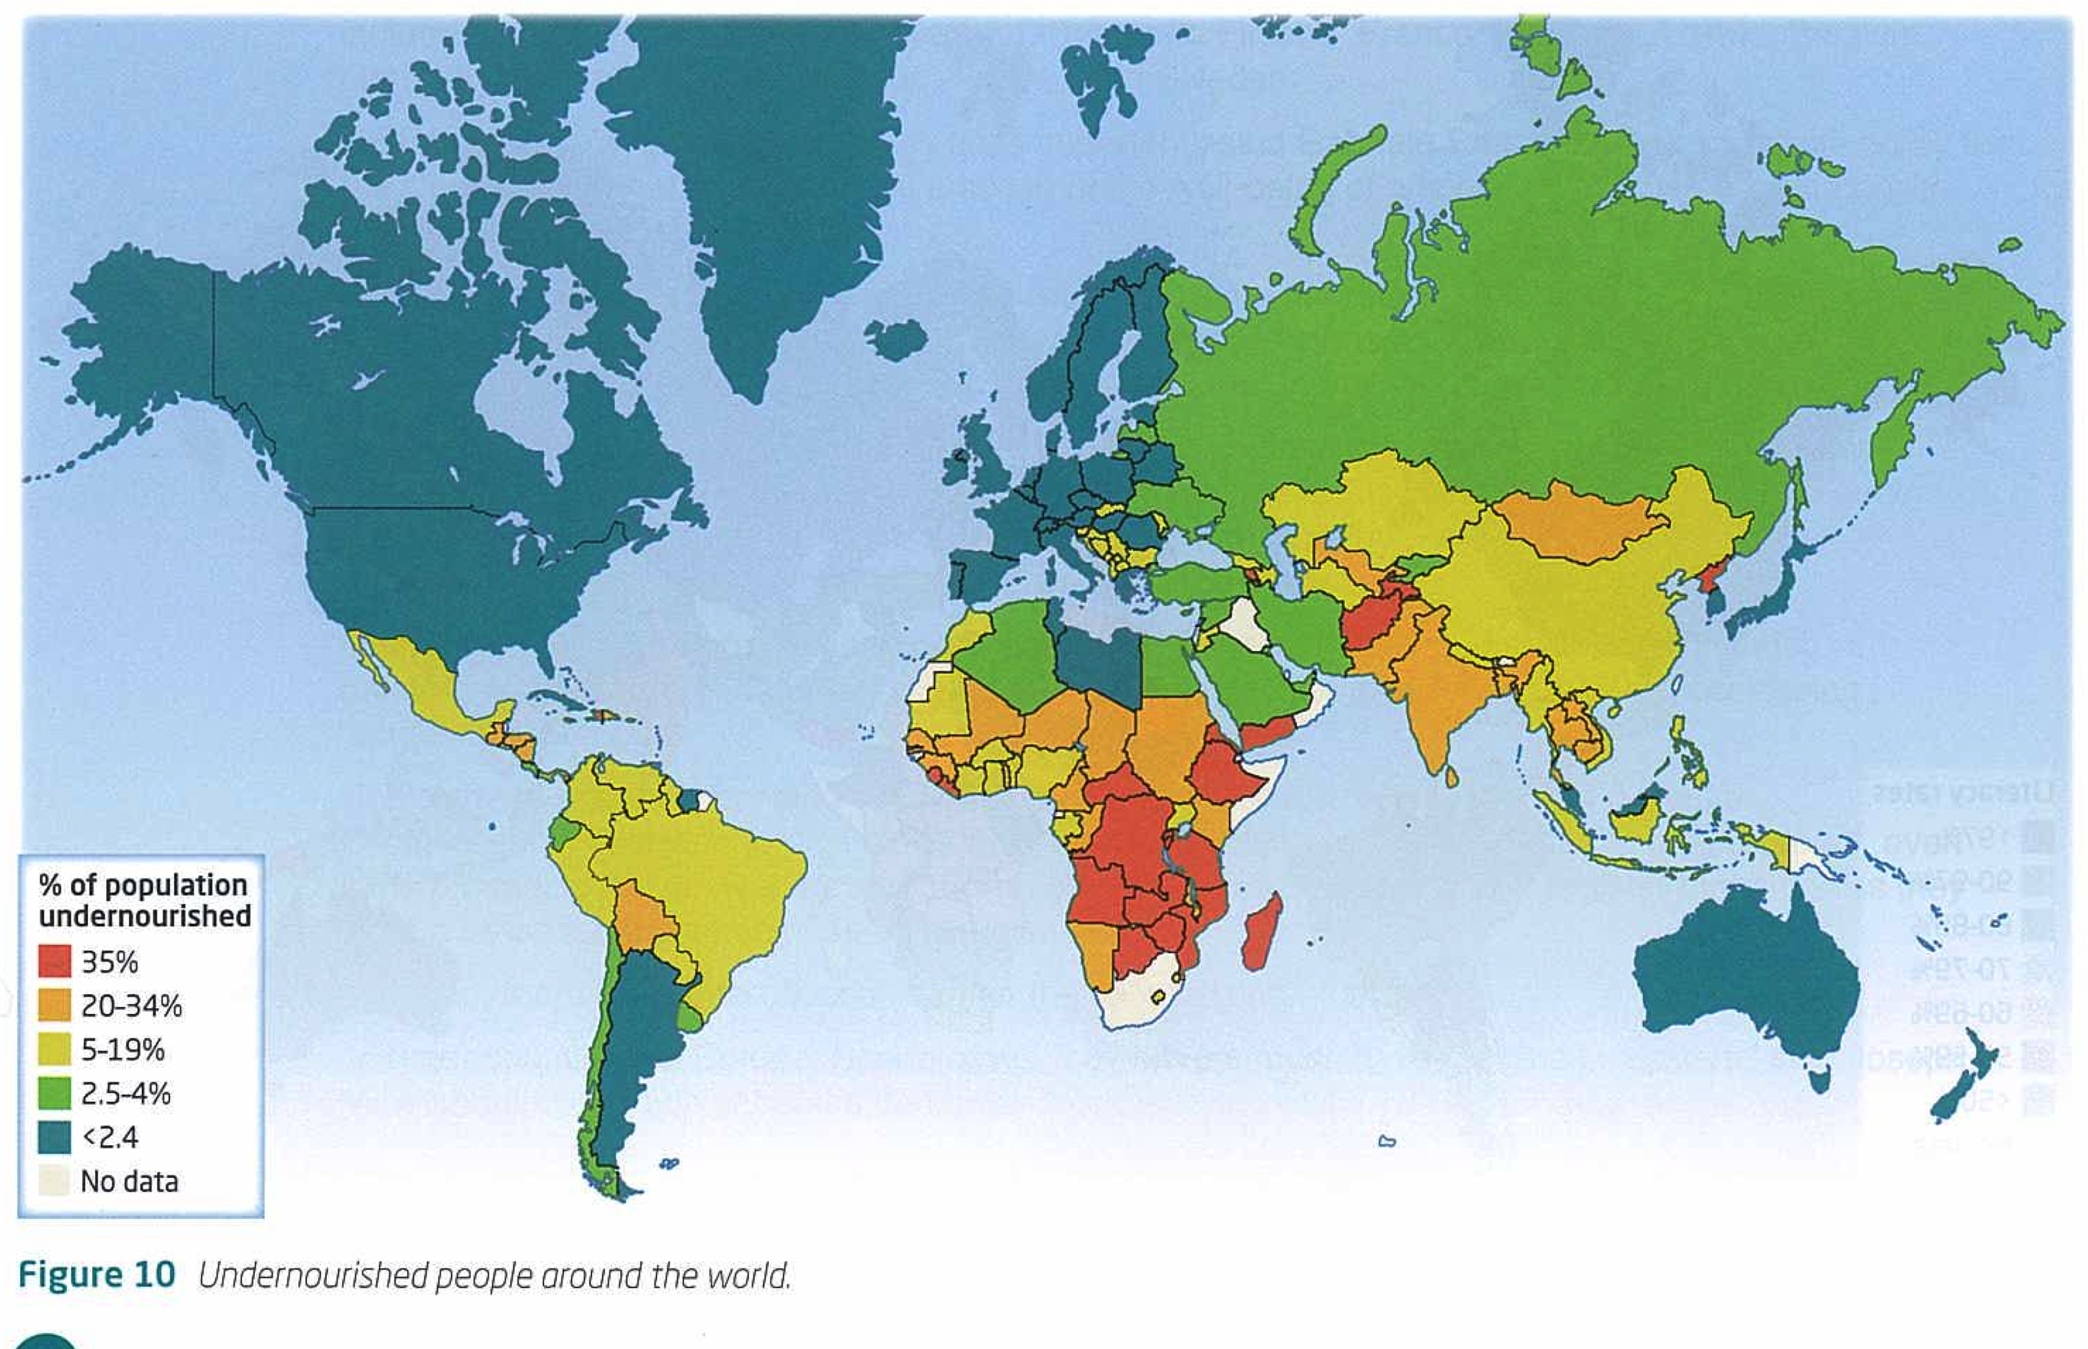
Nutrition
- Define malnutrition.
- Describe (don’t use the word because) the distribution (spread) of undernourished people around the world.

Make sure you:
- Name places
- Use data from the key
- Describe both where undernourished people are and where they are not.
- Describe the main patterns you observe.
- Identify any named anomalies.

Marginalisation
- Define marginalisation.
- Describe (don’t use the word because) the distribution (spread) of undernourished people around the world.

Make sure you:
- Name places
- Use data from the key
- Describe both where undernourished people are and where they are not.
- Describe the main patterns you observe.
- Identify any named anomalies.

