What are the Millennium Development Goals (MDGs)?

TASK:
Go to the following link to help you complete the table and questions below: http://www.un.org/Pubs/CyberSchoolBus/mdgs/flash/index.asp

- What happened at the United Nations Millennium summit in 2000?

- When is the target for achieving the MDGs?

- What does the Millennium Declaration promise to do?
______________________________________________________________________________
The Millennium Development Goals (MDGs)
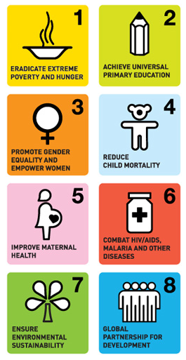

Millenium Development Goal (MDG) | Target | Interesting fact
1.
2.
3.
4.
5
6.
7.
8.

