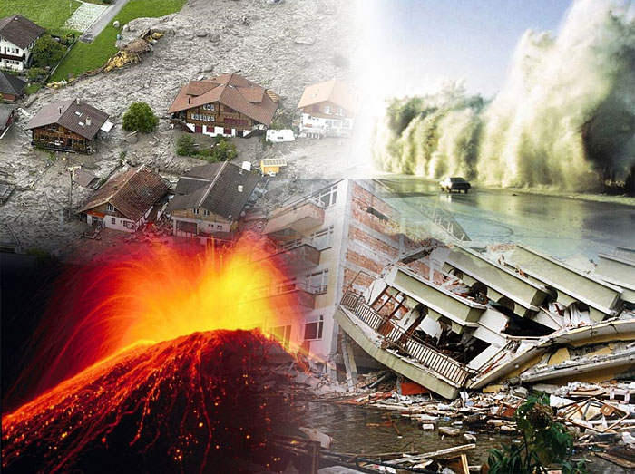
Natural disasters

Statement of Inquiry:
(Natural) disasters have
impacts on humans and the economy. Disasters are a motivating force for change in the human environment.
Inquiry Question: Can we control natural systems?

- In groups of 4 decide on a disaster below (each do something different)
- Create a PowerPoint of no more than 4 slides long
(If you finish before the others, you can help the others in
the group)
- Present the information to each other.

Investigate a recent disaster (in the last 25 years)
- Earthquake
- Tsunami
- Hurricane, typhoon, cyclone
- Volcanic eruption

- Summarise what happened. What were the impacts on people, on the environment, on the economy?
- How have humans reacted? What emergency procedures exist?
- How do they prevent the effects of disaster? Think about buildings, other structures, emergency plans

