Role card

Personnel Manager

You are looking for:
- cheap labour
- an educated workforce.

Key points:
- The higher the population density the cheaper the labour. Why do you think this is?
- Regions with a higher number of people going to school have more educated workers.

Role card

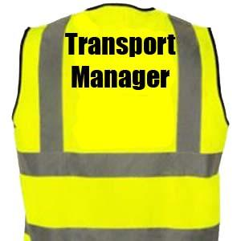

You are looking for:
- raw materials to bring to the factory.
- a way to distribute the finished cars.

Key points:
- Regions with lots of natural resources are important. Why?
- How will this affect the transport costs?

Role card

Sales Manager

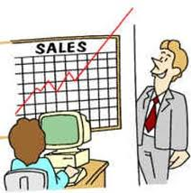

You are looking for:

- A good market to sell the finished cars.

Key points:

- You need people to buy the cars.
- They must be able to afford to buy the cars.

Role card

Production Manager

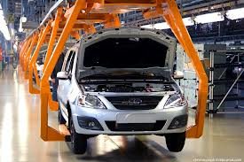

You are looking for:

- A good power supply.
- Efficient production.

Key points:

- Regions with the highest productivity are very important. Why?
- How much does each region contribute to Brazil’s gross domestic product (GDP)?

