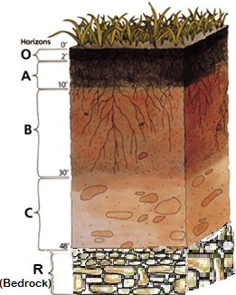

Complete research to answer the following questions:
- What is a pedologist and what do
they do?
- What is soil degradation?

