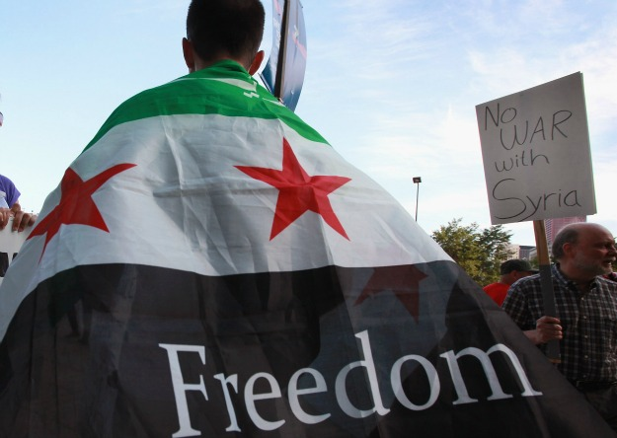
What’s happening in Syria?

- Who is the President of the Syrian government?

- How has the Red Cross described this?

- How many children are now refugees?

- How many people have died in the Syrian revolt?

- Where did the trouble start?

- What started the conflict between the Government and its people?

- Were the protests peaceful to begin with?

- What did the protesters want to begin with?

- What was the Syrian government blamed for using in Damascus?

- Why did the UN leave Syria?

- Does Syria have any allies?

- Why have no weapons been sent to help the Syrian revolt against the government?

- What is the USA going to do?

- What is the name of the Syrians revolting against the government?

